

|  |
| --- |
| **MATHEMATICS DEPARTMENT**  **Year 12 Methods - Test Number 3 - 2017  Applications and Integration**  **RESOURCE RICH - SOLUTIONS** |

Multiple-choice questions [2 marks each]

1 y = 3x3 + 4x2+5

y′ = 9x2 + 8x

When x = 2

y′ = 52

δy = 52 × 0.03

= 1.56

D

2  y = 2x3 +12x2 – 18x – 5

y′ = 6x2 + 24x – 18

y″ = 12x + 24

concave upwards when y ″ > 0

12x + 24 > 0

12x > –24

x > –2

 B

3 Let the two numbers be x and y.

Then xy = 72 and the sum S = 2x + 4y



Substitute into S = 2x + 4y

S = 2x + 4

S = 2x + 

 = 2 – 

Stationary point when  = 0,

2 –  = 0

2x2 = 288

x2 = 144, since x is positive

x = 12

y = 

y = 6

 A

4 The width of each rectangle is 0.25 units and the centres are at x = 0.125, 1.375, 1.625 and 1.875

Heights are f(1.125) = 1.1254, f(1.375) = 1.3754, f(1.625) = 1.6254 and f(1.875) = 1.8754

A = 0.25 × 1.1254 + 0.25 × 1.3754 + 0.25 × 1.6254 + 0.25 × 1.8754

= 0.25 × (1.1254 + 1.3754 + 1.6254 + 1.8754)

∴ D

5 The algebraic area between x = – 4 and x = 1 is negative, so  will give the physical area.

∴ E

6 





∴ A

7 





∴ B

**8**  The algebraic area between x = 1 and x = 3 is negative, so  will give the physical area.

∴ B

9 

= – cos – [– cos(0)]

= –  + 1

= 

= 

∴ B

10 Total change = 

= 

= 

= 

= 50e1  50e0

= 85.914…

∴ B

11 a The average score is decreasing.

[1 mark]

b The rate at which the average score is decreasing is increasing.

[1 mark]

c [**1 mark]** for concave downwards for x

**[1 mark]** for decreasing curve

**[1 mark]** for y-intercept of 38

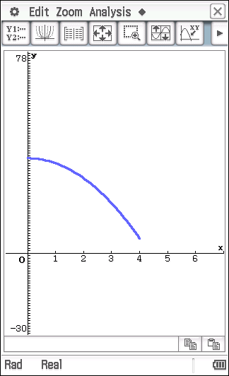

12 Volume = πr2h

500 = πr2h [1 mark]

 [1 mark]

Surface area = 2πr2 + 2πrh

|  |  |
| --- | --- |
|  | [1 mark]  [1 mark]  [1 mark]  [1 mark] |

**13 a ** **[1 mark]**

= (32 – 9 × 3) – (12 – 9 × 1)

= 9 – 27 – 1 + 9

= – 10 **[1 mark]**

**b** **[1 mark]**



= e6 – e2 **[1 mark]**

= e2(e4 – 1)

**c** **[1 mark]**



= sin(π) – sin(0)

= 0 – 0

= 0 **[1 mark]**

**d** **[1 mark]**



= 22 **[1 mark]**



**14 a **

**[1 mark]**



 **[1 mark]**

= 0 **[1 mark]**

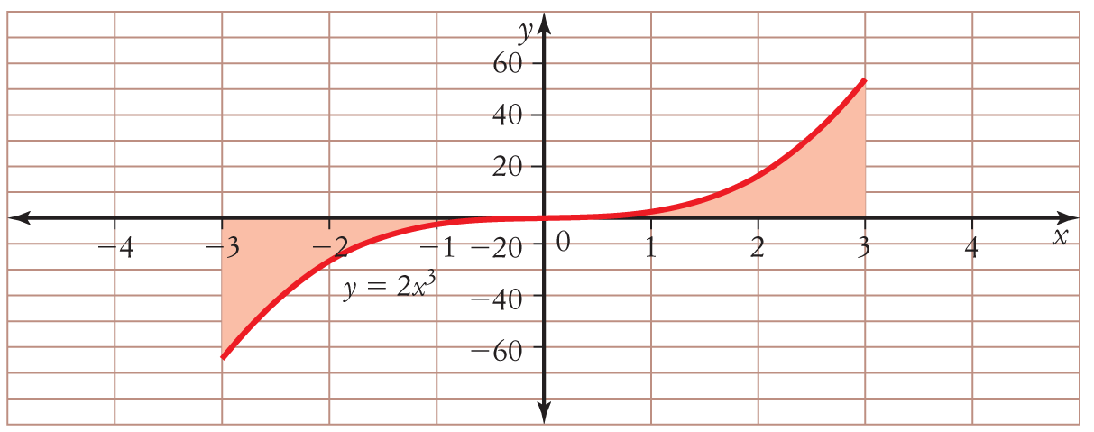**b**

**[1 mark]**



 **[1 mark]**

= 34 – 04

= 81

The area is 81 units2. **[1 mark]**

**15** = 8*x* − 7



*y* = 4*x*2 − 7*x* + *c* **[1 mark]**

*y* = 13 when *x* = −1, so 13 = 4 × (−1)2 − 7 × −1 + *c*

13 = 11 + *c*

*c* = 2 **[1 mark]**

*y* = 4*x*2 − 7*x* + 2 **[1 mark]**

16 Swim to a point approximately 0.89 km along the river towards his camp and then walk approximately 0.11 km to his camp. This will take approximately 42 minutes 22 seconds.

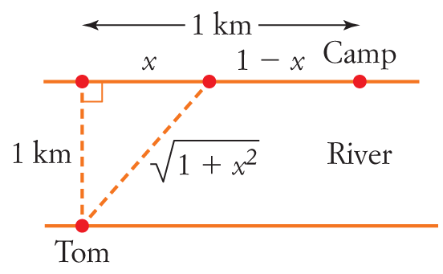

Swim: 2 km/h, Walk: 3 km/h



Time = Swim time + Walk time

|  |  |
| --- | --- |
|  | [1 mark]  [1 mark]  [1 mark]  [1 mark]  [1 mark] |

Substitute into T to find T ≈ 0.706 hours ≈ 42 minutes 22 seconds [1 mark]

**17 a** **[1 mark]**



**[1 mark]**



**b** **[1 mark]**



**[1 mark]**



**[1 mark]**



**[1 mark]**

